The architecture of Tiers for web servers

Types of Architecture:

* One-Tier Architecture
* Two-Tier Architecture
* Three-Tier Architecture
* N-Tier Architecture
* One-Tier Architecture:

What is one-tier Architecture and how it works?

In basic terms, **One-Tier Architecture** is where the client (user) interacts with an application that has all its components **application logic, user interface, and database** on the same machine. In this setup, if the client requests the application on the web browser, the application retrieves and processes the data directly from the local database, since everything is housed within the same system.

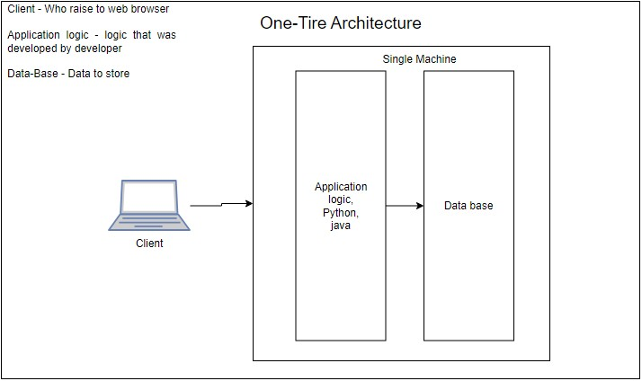

.

* Two-tier architecture:

Two-tier architecture refers to a client-server architecture where the user interface and the database are separated into two tiers

1. Presentation Layer
2. Server layer

* Presentation Layer: This is the front-end layer where the user interacts with the application. It runs on the client side, within a web browser. The Client tier includes the user interface and the logic that handles user inputs, sends requests to the server, and displays the results.
* Sever layer (or) Data layer: This is the back-end layer where the data is processed and stored. The server tier handles the business logic, processes client requests, and interacts with the database to store or retrieve data. It then sends the processed information back to the client tier for display.

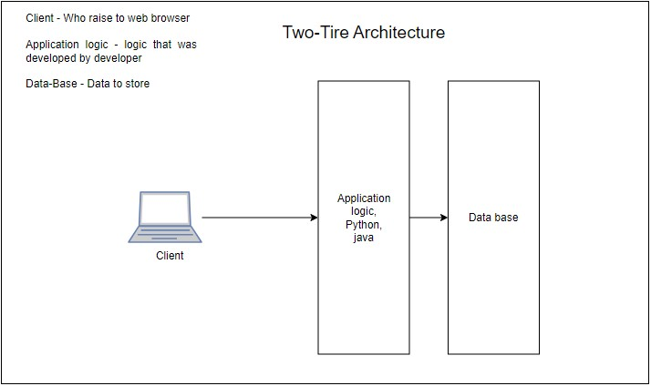

How the two-tier architecture works

* Users-side – The user sends a request to the server for some information
* Server-side – The server processes this request, interacts with the database if needed, and sends the response back to the client.
* User-side – The browser receives the response and displays the content to the user.

Three-Tier Architecture:

Three-tier architecture is a way of organizing software applications into three separate layers or tiers.

1. Presentation Layer
2. Logic layer
3. Data layer

* Presentation Layer: This layer is where users interact with the application, Like the screens and buttons you see on a website
* Logic layer: This is where the application's main processing happens, like data processing, and logical, decision-making based on user's action
* Data layer: This is where the application data is stored and retrieved, like user information and other data need to work web site or application

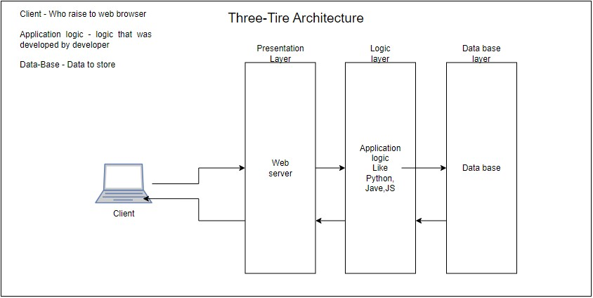

How the Three-tier architecture works

* Users-side – The user sends a request to the server for some information
* Web server – The web server receives the request and verifies the client details sends the request to the logic layer
* Logic layer – The logic layer works as a decision-making to get permission and data from data base
* Server-side – The server processes this request, interacts with the database if needed, and sends the response back to the client.
* User-side – The browser receives the response and displays the content to the user.

N-Tier Architecture:

N-tier architecture is a software design pattern that separates an application into different layers or “tiers”, each with distinct responsibilities. This separation allows for more modular, scalable, and maintainable systems. Typically, these layers are organized

1. Presentation Layer
2. Application Layer
3. Data layer
4. Integration layer(Load balancers, APIs, Other services)

* Presentation Layer: This layer is where users interact with the application, Like the screens and buttons you see on a website
* Logic layer: This is where the application's main processing happens, like data processing, and logical, decision-making based on the user's action
* Data layer: This is where the application data is stored and retrieved like user information and other data needed to work web site or application
* Integration layer: In some architectures, an additional tier is used to handle integration with external systems like load balancers, APIs, and Other services.

